ARM Assembly

**Part A**

The above images are the registers with the solution and the code of the tutorial ARM Assembly program. This tutorial gave me a better understanding of loading memory into the registers through the variables that are already in .data. The coding in ARM is different compared to x86 because in ARM we need to load the address of the variable first and then load the actual value. After loading the address and values the actual arithmetic is calculated and the result is stored, which is 7.

**Part B**

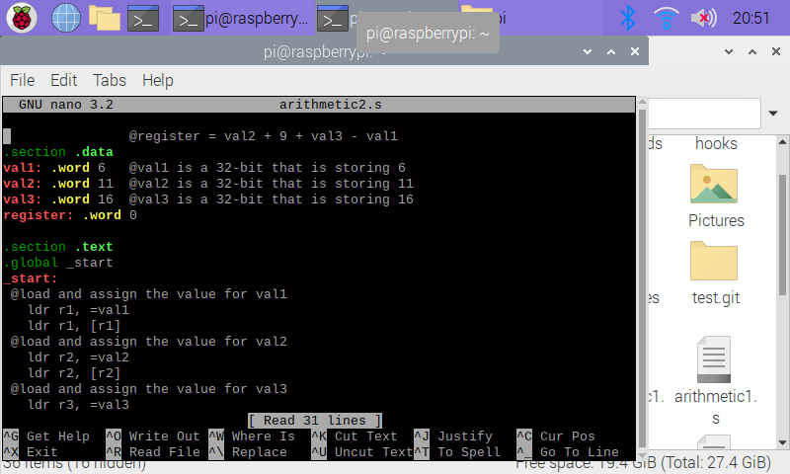

As stated above I first had to store the values of the variables in the .data section. Then I loaded the variable address’s and then their values from the given equation, register = val2 + 9 + val3 – val1. Later, I computed the actual arithmetic of the equation, by using the registers and the immediate value. After this I loaded the register the stored the final result into it, which is 30.